ICS344 - Information Security – Section 4

Student Name(s) + ID(s):
Abdulwahab Badirah 202160410
Yazed almutairi 202164390
Abdulmuhaymin Althabit 202275600
Mohammed Alfaraj 202323090
DVSA Website URL:
AWS Region: N. Virginia (us-east-1)
Date: 5/3/2026
Vulnerability Title(s): Over-Privileged Function

Goal and Vulnerability Summary
This lesson demonstrates an over-privileged function vulnerability in the DVSA serverless application. The affected component is the IAM execution role attached to the DVSA-SEND-RECEIPT-EMAIL Lambda function — serverlessrepo-OWASP-DVSA-SendReceiptFunctionRole-duYHdeWc4vyt. This function's sole purpose is to send a receipt email to a customer after an order is completed. However, its execution role grants it far more AWS permissions than it needs, including broad S3 access across all buckets, full DynamoDB access across all tables, and the ability to reveal its own AWS STS credentials. If an attacker is able to trigger this function maliciously or extract its temporary credentials, they can inherit all of these excessive permissions and use them to read, write, delete, or scan any resource in the AWS account. The core weakness is a violation of the Principle of Least Privilege at the IAM layer.

Why This Works / Root Cause
The vulnerability exists because the Lambda execution role was configured with three inline policies that grant permissions far beyond what the function requires. Policy 1 grants eight S3 actions including PutObject, DeleteObject, and PutObjectAcl on all buckets (arn:aws:s3:::*). Policy 2 grants ten DynamoDB actions including DeleteItem, Scan, BatchWriteItem, and UpdateItem on all tables in the account. Policy 3 grants sts:GetCallerIdentity on all resources, which allows the function to reveal its own temporary AWS credentials. A send-receipt function only needs to read one specific S3 bucket to retrieve the receipt file and send it via SES. All other permissions are unnecessary and create a large blast radius if the function is ever compromised or abused.

Environment and Setup
- Vulnerable Lambda Function: DVSA-SEND-RECEIPT-EMAIL
- Execution Role: serverlessrepo-OWASP-DVSA-SendReceiptFunctionRole-duYHdeWc4vyt
- Over-privileged Policies: SendReceiptFunctionRolePolicy1, SendReceiptFunctionRolePolicy2, SendReceiptFunctionRolePolicy3
- AWS Region: us-east-1
- Tools used: AWS IAM Console, IAM Policy Simulator, AWS CloudShell

Reproduction Steps
- Go to AWS Console → IAM → Roles
- Search for SendReceiptFunctionRole and click the role
- Click the Permissions tab observe 5 policies attached: AmazonSESFullAccess, AWSLambdaBasicExecutionRole, and three customer inline policies
- Click Simulate on the role
- Select the function and test

- All show allowed confirming the function has far more permissions than needed

Evidence and Proof
The following evidence confirms the over-privilege vulnerability:
- Policy 1 JSON showed 8 S3 actions
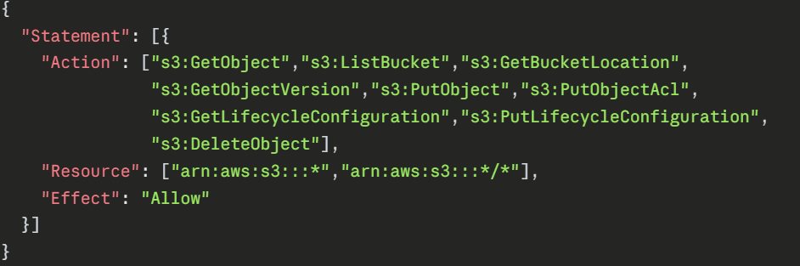
meaning all buckets in the account
- Policy 2 JSON showed 10 DynamoDB actions
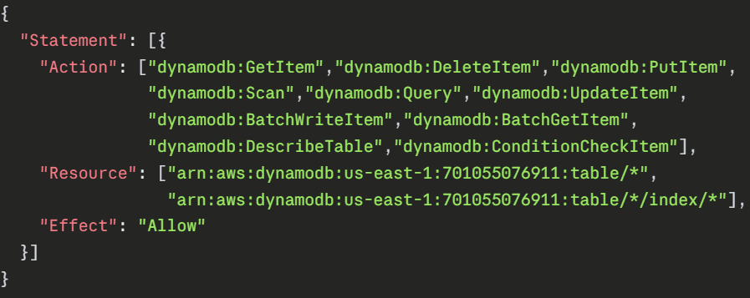
meaning all tables in the account.

- Policy 3 JSON showed
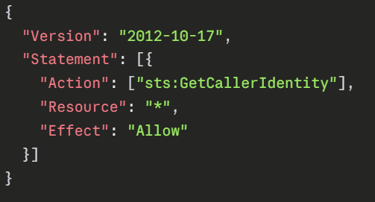
allowing the function to expose its own temporary credentials.
- IAM Policy Simulator confirmed that
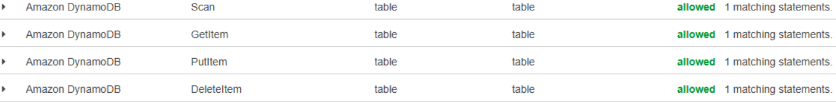
were all allowed on wildcard resources before the fix.

Fix Strategy / Probable Mitigation
The fix belongs at the IAM execution role layer. The principle of least privilege requires that each Lambda function is granted only the exact permissions it needs to perform its intended task — nothing more. For DVSA-SEND-RECEIPT-EMAIL, the function only needs to read a receipt file from one specific S3 bucket. Therefore the fix is to restrict Policy 1 to only s3:GetObject on the specific receipts bucket, restrict Policy 2 to only dynamodb:GetItem on the orders table if database access is needed at all, and delete Policy 3 entirely since sts:GetCallerIdentity serves no legitimate purpose for this function. This approach minimizes the blast radius: even if the function is compromised, an attacker inheriting its credentials gains almost nothing useful.

Code / Config Changes
Resource changed: IAM Role — serverlessrepo-OWASP-DVSA-SendReceiptFunctionRole-duYHdeWc4vyt
- Policy 1:
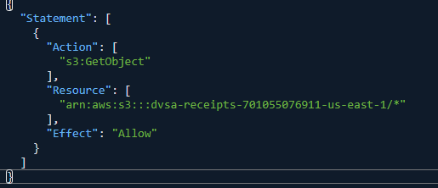
- Policy 2:
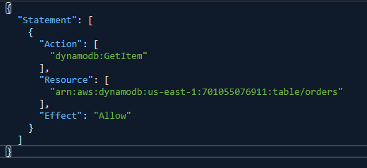
- Policy 3:
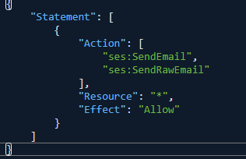

Verification After Fix
After applying all three fixes, the IAM Policy Simulator was run again on the same role with the same actions:
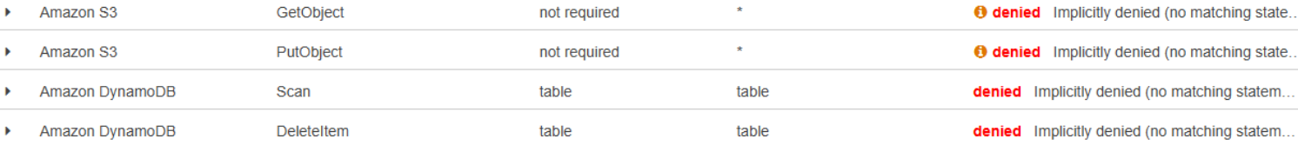
The function retains only the minimum permissions needed to perform its intended task. Legitimate receipt sending functionality is preserved while all excessive permissions are removed.

Structured Operation and Security Analysis
Table 1: Structured analysis summary — Table A
Vulnerability | Intended Rule(s) | Artifacts Used to Infer Rule | Normal Behaviour Evidence | Exploit Behaviour Evidence
Over-Privileged Function | The DVSA-SEND-RECEIPT-EMAIL function must only hold the minimum permissions required to send a receipt email. It must not have write, delete, or scan access to S3 or DynamoDB resources beyond what the email workflow requires. | IAM role permissions tab showing 3 inline policies; Policy JSON for all three policies; IAM Policy Simulator results; DVSA function purpose (send email only). | The function sends a receipt email after an order. It should only read the specific receipt file from the receipts S3 bucket. All other AWS actions should be denied. | IAM Policy Simulator confirmed S3 PutObject, S3 GetObject on all buckets, DynamoDB Scan, DynamoDB DeleteItem, and DynamoDB PutItem were all allowed on wildcard resources far beyond the function's intended scope.

Table 2: Structured analysis summary — Table B
Vulnerability | Why This Is a Deviation | Deviation Class | Fix Applied (Where) | Post-Fix Verification | Optional Latency Before / After Logging
Over-Privileged Function | The intended rule requires minimum permissions for the send-receipt task. Instead the role granted 8 S3 actions on all buckets, 10 DynamoDB actions on all tables, and STS credential exposure — creating a massive blast radius if the function is ever compromised. | Accidental Misconfiguration | IAM execution role: restricted Policy 1 to s3:GetObject on receipts bucket only; restricted Policy 2 to dynamodb:GetItem on orders table only; deleted Policy 3 entirely. | IAM Policy Simulator confirmed PutObject, Scan, DeleteItem, and cross-bucket GetObject all denied after fix. Legitimate s3:GetObject on receipts bucket remains allowed. | No latency measurements taken. IAM Policy Simulator used as primary verification tool before and after fix.

Takeaway / Lessons Learned
The core security assumption that failed here was that a Lambda function's execution role was configured with broad permissions during development and never narrowed down before deployment. This is an extremely common pattern in serverless applications developers often grant wide permissions to get things working quickly and then forget to restrict them. In a serverless environment this is especially dangerous because Lambda functions are internet-facing by design. An attacker who finds a way to abuse or inject into a function immediately inherits all of its IAM permissions, potentially gaining access to every S3 bucket, every DynamoDB table, and the ability to impersonate the function's identity across the entire AWS account.
The general secure design principle that applies here is the Principle of Least Privilege. Every Lambda function should be granted only the exact AWS actions it needs, on only the exact resources it needs, and nothing more. IAM roles should be reviewed and tightened before deployment, and tools like IAM Access Analyzer and the IAM Policy Simulator should be used regularly to detect and eliminate excessive permissions across all serverless functions.

